**Day 1 Lab Assignments**

**Do the following Assignments:**

1. Start to create your personal website, create new folder that will contains all site pages and another new folder inside it for website resources (images, media,...).
2. Create welcome page and name it (welcome.htm) that contains a welcome statement and your name in new line, and welcome image on the center of the page.
   1. Change the font and color of the welcome statement.
   2. Change the background color of the page.
   3. Make the page after 5 seconds; redirect the user to another page named (Home.htm).
   4. Make (skip Intro) link on the center bottom of the page that skips welcome page, and opens (Home.html) page in the same browser window.
3. Create the Home page and name it (Home.html), and add the following on it (as shown in the image below):
   1. Add your Name in the center of the page as the page main header
   2. Add your personal information in bullet list on the left.
   3. Then put your personal photo (on the right),
   4. Finally add a brief about yourself (Make a long text on about me, to show vertical scroll on the page, and so you need to scroll to reach the end of the page)
   5. Change your name to be in Arabic?
      1. You need to use meta tag to change the page character encoding, what is it?
   6. Add horizontal line after “about me” section, and then Create div in the bottom of home page (after the horizontal line) include 3 links (Home, About, Contact me) to (top part of home page (bookmark), page named About.htm, page named Contact.htm).
   7. In the footer add your social media links (each one is an image link, when clicked opens the clicked social profile in a new window).
   8. Handle the below image, to be a link to the top of page (Bookmark).
   9. The home page should look as the following after you finish it:

|  |  |
| --- | --- |
| **Your Full name** | |
| My personal info:  Personal Photo   * Age: * Address: * Phones: * Faculty name (as a link to your faculty website, that opens in a new window) * Graduation year * Hobbies * [Send me Email](#email link) (Mail Link) |  |
| About me: | |
| [**home** **contact us** **about**](http://www.ironspider.ca/webdesign102/tables4layout2.htm)  Image result for social media links  **Copyrights © are reserved to ITI.** | |

1. Create new page and name it (About.htm), and write about yourself using text formatting and appearance tags.
2. Create Registration page with the following fields (Don’t use tables with the form):
   * User ID (Hidden field)
   * First name (Required)
   * Last Name (Required)
   * Email (Required, Email)
   * Password (password)
   * Repeat password (password)
   * Birth Date (Date)
   * User Picture (file input)
   * Gender [Male of Female] (Radio button, in fieldset)
   * Faculty (Dropdown list)
   * Interests [Programming, reading, swimming,..](Checkbox in fieldset)
   * About you (Text area)
   * I agreed to terms and condition checkbox (make the label next to it as a link to terms and condition page that opens in new tab)
   * Submit and reset buttons

**Use the following with the form:**

1. Labels instead of plain text for form elements
2. Adjust tab index and use access key.
3. HTML 5 new inputs and validation attributes.
4. Submit button redirect user to page named (Thankyou.htm), which contains text:

**Thank you for your registration.**

1. Use “get” method.
   1. What are the differences between “get” and “post” methods?

**Self-Study Assignments (Bonus):**

1. Replace any deprecated tags and attributes in your pages to be HTML5 Valid.
2. Put a back ground sound on (welcome page), that runs automatically when the page loads (use audio tag).
   1. Most browsers are blocking the auto play sound in pages currently; in this case you can make the audio start by user normally.
3. Replace the image in the welcome page, to be a full-page background image (like this one: <https://www.w3schools.com/howto/tryhow_css_fullpage_demo.htm> )
4. Display a video in your home page in any place (use video tag).
   1. Try to make the video as Fullscreen Video Background in home page or welcome page (like this one here: <https://www.w3schools.com/howto/howto_css_fullscreen_video.asp> )
5. Set a favicon for your page.
6. Try iframe on your home page.
7. Design a single page website like the following (You can make it as a personal CV for yourself):

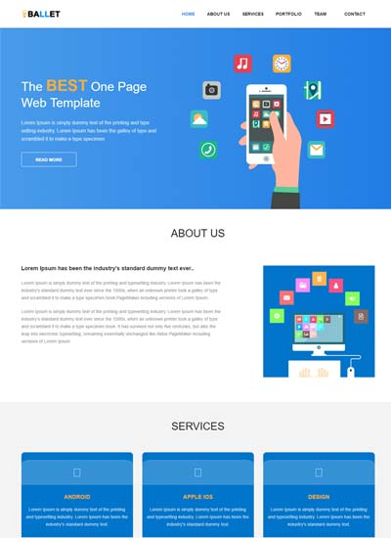

1. Use Image map in new page.
2. What are Back-links? (With example)
3. What’re meta tags? And what’re its benefits and uses? (With example)
4. What are the meta tags for social media? And what are its uses? (With example)
5. What are search engines? And how it work?
6. What’s SEO?
7. How to optimize your website for search engines?

**<Thank> YOU </Thank>**